VOIP lab experiment#12
Creating a ring group in the PBX

Installation and Repair of Telecommunications Equipment

Name of student:________________
Group Number:_________________
Date:_________________________

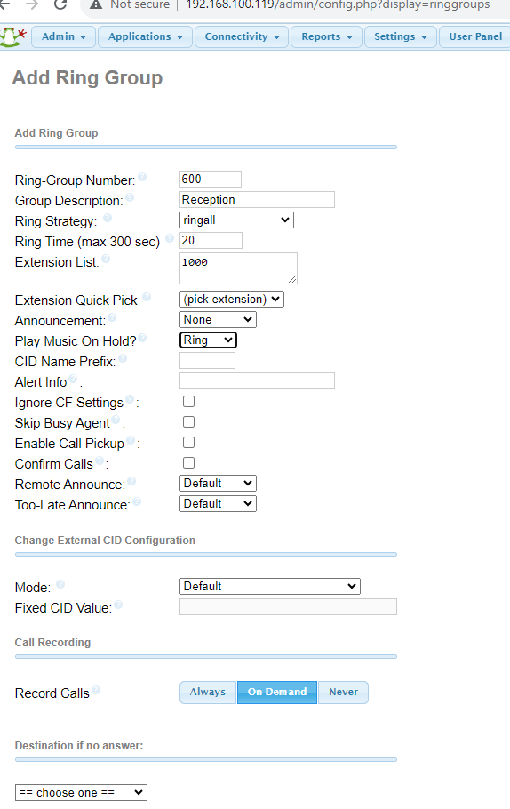
The purpose of the lab is to create a ring group for the company in the PBX. A ring group is when a group of person phone ring at the same time.
- Enter a group description
- Enter extension quick pick, choose the extension for the group so the extensions will appear in extension list.

- Go to destination if no answer, choose voicemail and then choose an extension and choose any extension.

- Click on save and then apply config

CHANGE YOUR INCOMING ROUTE to this group

